1.Real-Time Streaming Data Integration Enhancement

Current System
The current architecture processes batch CSV files manually placed inside the data/clinical directory. FastAPI reads the CSV and performs preprocessing and observability analysis.

Future Enhancement
The enhanced architecture enables continuous real-time clinical data ingestion through APIs that can be taken by AI System for observability Check and store it.

Updated Architecture Flow
1.Hospital APIs / EDC Systems
2.Apache Kafka
3.Streaming Consumer
4.FastAPI Processing
5.Observability Agents

Step 1 — Data Source APIs
Hospitals and laboratories expose APIs that continuously send patient records, side effects, glucose levels, and treatment updates to the platform.

Step 2 — Kafka Streaming
Instead of storing uploaded CSV files, the APIs publish real-time patient events into Apache Kafka topics such as clinical_trial_events.

Step 3 — Streaming Consumer
Python Kafka Consumers continuously read streaming events from Kafka topics and pass them into the preprocessing layer.

Step 4 — Real-Time Preprocessing
The preprocessing layer continuously computes observability metrics such as freshness, volume, schema validation, drift detection, and anomaly monitoring in real time.

Step 5 — Snowflake Storage
Processed streaming data and observability metrics are stored in Snowflake for enterprise analytics, reporting, and historical analysis.

Step 6 — Real-Time Observability
AI agents continuously monitor streaming ingestion failures, API delays, Kafka consumer lag, schema drift, and operational anomalies.

New Components Added
Apache Kafka for event streaming, Snowflake for analytics storage, and API Gateways for hospital integrations.

Enhanced ETL Logs
The ETL logging layer now captures streaming operational events such as Kafka failures, API timeouts, ingestion delays, and consumer disconnects.

Benefits
The enhancement enables continuous monitoring, instant anomaly detection, reduced manual effort, scalable healthcare ingestion, and enterprise-grade real-time observability.

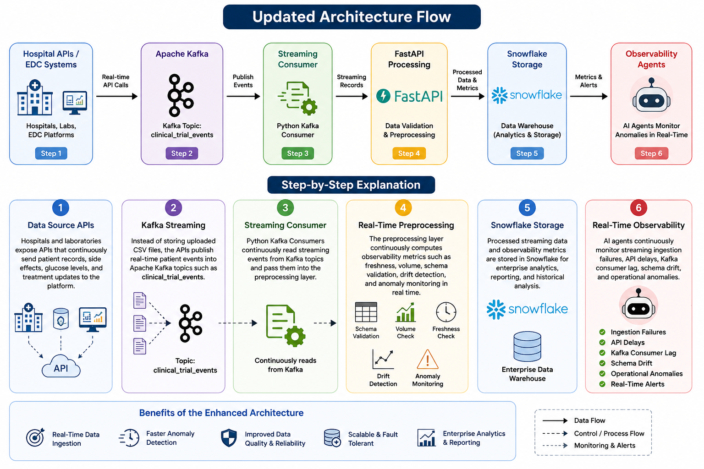

Kafka Helps With
- real-time ingestion
- live anomaly detection
- streaming observability

Snowflake Helps With
- historical storage
- enterprise analytics
- dashboard reporting
- large-scale querying

HOW AGENTS CHANGE

1.Data Quality Agent
Now analyzes:
- real-time observability metrics

2.Log Analysis Agent
Now monitors:
- API logs
- stream failures

3.RCA Agent
Can detect:
Hospital API latency caused delayed clinical ingestion.

BENEFITS
Before | After
Batch monitoring | Real-time monitoring
Delayed detection | Instant detection
Manual uploads | Continuous ingestion
Static analysis | Live observability

